**Experiment no. 5**

**Aim: To study frequency response of a single-stage and multi-stage RC coupled Common Emitter Transistor Amplifier using Proteus.**

**Software required: Proteus 8.**

**Theory:**

**Single-Stage Common Emitter RC coupled Transistor Amplifier:**

The circuit diagram of a single-stage common emitter RC coupled amplifier using transistor is shown in the figure below.

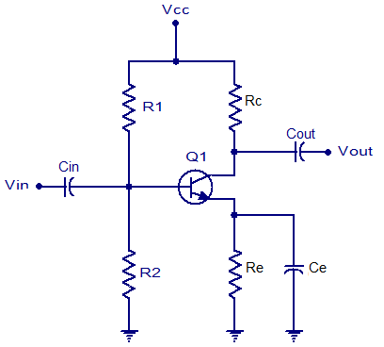

Capacitor Cin is the input DC decoupling capacitor which blocks any DC component if present in the input signal from reaching the Q1 base. If any external DC voltage reaches the base of Q1, it will alter the biasing conditions and affects the performance of the amplifier.

R1 and R2 are the biasing resistors. This network provides the transistor Q1′s base with the necessary bias voltage to drive it into the active region. The region of operation where the transistor is completely switched off is called cut-off region and the region of operation where the transistor is completely switched ON (like a closed switch) is called saturation region. The region in between cut-off and saturation is called active region. For a transistor amplifier to function properly, it should operate in the active region.

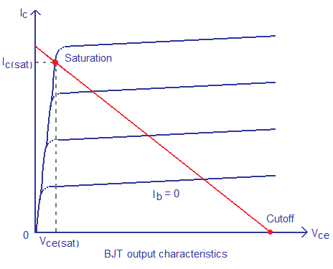

Cout is the output DC decoupling capacitor. It prevents any DC voltage from entering into the succeeding stage from the present stage. If this capacitor is not used the output of the amplifier (Vout) will be clamped by the DC level present at the transistors collector.

Rc is the collector resistor and Re is the emitter resistor. Values of Rc and Re are so selected that 50% of Vcc gets dropped across the collector & emitter of the transistor. This is done to ensure that the operating point is positioned at the center of the load line. 40% of Vcc is dropped across Rc and 10% of Vcc is dropped across Re. A higher voltage drop across Re will reduce the output voltage swing and so it is a common practice to keep the voltage drop across Re = 10%Vcc. Ce is the emitter by-pass capacitor. At zero signal condition (i.e., no input) only the quiescent current (set by the biasing resistors R1 and R2 flows through the Re). This current is a direct current of magnitude few milli-amperes and Ce does nothing. When input signal is applied, the transistor amplifies it and as a result a corresponding alternating current flows through the Re. The job of Ce is to bypass this alternating component of the emitter current. If Ce is not there, the entire emitter current will flow through Re and that causes a large voltage drop across it. This voltage drop gets added to the Vbe of the transistor and the bias settings will be altered.

The frequency response of a single stage RC coupled transistor is shown in the figure below. Points P1 and P2 are the lower and upper half power points respectively.

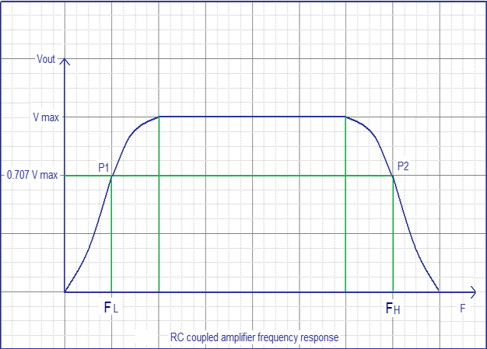

**Multi-Stage Common Emitter RC coupled Transistor Amplifier:**

The circuit diagram of a multi-stage common emitter RC coupled amplifier using transistor is shown in the figure below.

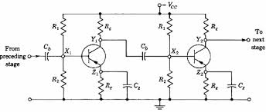

When a.c. signal is applied to the base of the first transistor, it is amplified and developed across the output of the first stage. This amplified voltage is applied to the base of next stage through the coupling capacitor Cb where it is further amplified and reappears across the output of the second stage. Thus the successive stages amplify the signal and the overall gain is raised to the desired level. Much higher gains can be obtained by connecting a number of amplifier stages in succession (one after the other).

Resistance-capacitance (RC) coupling is most widely used to connect the output of first stage to the input (base) of the second stage and so on. It is the most popular type of coupling because it is cheap and provides a constant amplification over a wide range of frequencies.

**Result:-**

**Conclusion:-**